Software Requirement Specification for On-Duty tracker

|  |  |
| --- | --- |
| **Name:** | FATHIMA ZUHAIRA S M |
| **Roll No:** | 7376221EC157 |
| **Seat No:** | 356 |
| **Project Id:** | 36 |
| **Project Title:** | On-Duty Tracker |

## Introduction:

This document outlines the development of a web application called "On-Duty Tracker" built with Python and the Django framework. This application is designed to track student participation in specific events.

## Purpose :

The purpose of creating this project is to facilitate easy tracking of student locations during their participation in events. This will greatly assist the faculty in efficiently monitoring the students.

## Scope of the project :

* + - The scope of the project entails developing a portal to track the location of students while they attend events. Once a student logs in to the portal, they will be granted access. Upon accessing the portal, users will share their location , and they will need to share their location in order to activate the geotag feature.
    - The project aims to enable administrators to effortlessly track whether students have attended an event or not. This streamlined process will significantly assist in efficiently approving certificates for the students who have attended the event.

## System over view :

* 1. **users :**

## Student:

Students have the ability to log in, share their location, book their reward review slot and upload proof of their event in the form of certificates. The geotag feature will be activated only after the student enables location sharing.

## Administrative:

Administrators can track the location of students to determine whether they have attended the event or not. This information is crucial for the approval of certificates.

## Feature:

1. **User access:**

## Google Sign-In:

Users are required to sign in with a specific Google account. If the user attempts to sign in with any other Google account, an invalid user message will be displayed. This is because we have already stored the user's specific account information in our database.

## On-Duty Tracker (Home Page):

After completing the Google Sign-In process, we are directed to the home page. On the home page, we have five modules:

* + - 1.Resource
    - 2.Student Name
    - 3.Academic FA Percentage
    - 4.Placement FA Percentage
    - 5.OD Date and Time

These modules provide various functionalities and information for tracking on-duty activities.

## 1.Resource Page:

On the resource page, we have three modules: a.Location

b.Geo Tagged Camera c.Certificate Proof d.Reward Review Slot

These modules offer different functionalities and options related to resources.

## Geo-Tagged Camera:

When you enter the Geo-Tagged Camera feature, the system prompts you to enable your location. If you enable the location, you will be granted access to the camera. However, if you do not enable the location, you will not be allowed to use the Geo-Tagged Camera functionality.

## Certificate proof:

A student can access the certificate upload page and upload their event proof without sharing their location. The certificate proof page consists of nine modules:

* 1. Student Name:
  2. Location
  3. Title of the event
  4. Developed by individual or group
  5. Mode of participation
  6. Status
  7. Category of the event
  8. From date
  9. To date
  10. Abstract
  11. Certificate proof (in PDF format)
  12. Geotag proof (in image format)

## User’s Interface:

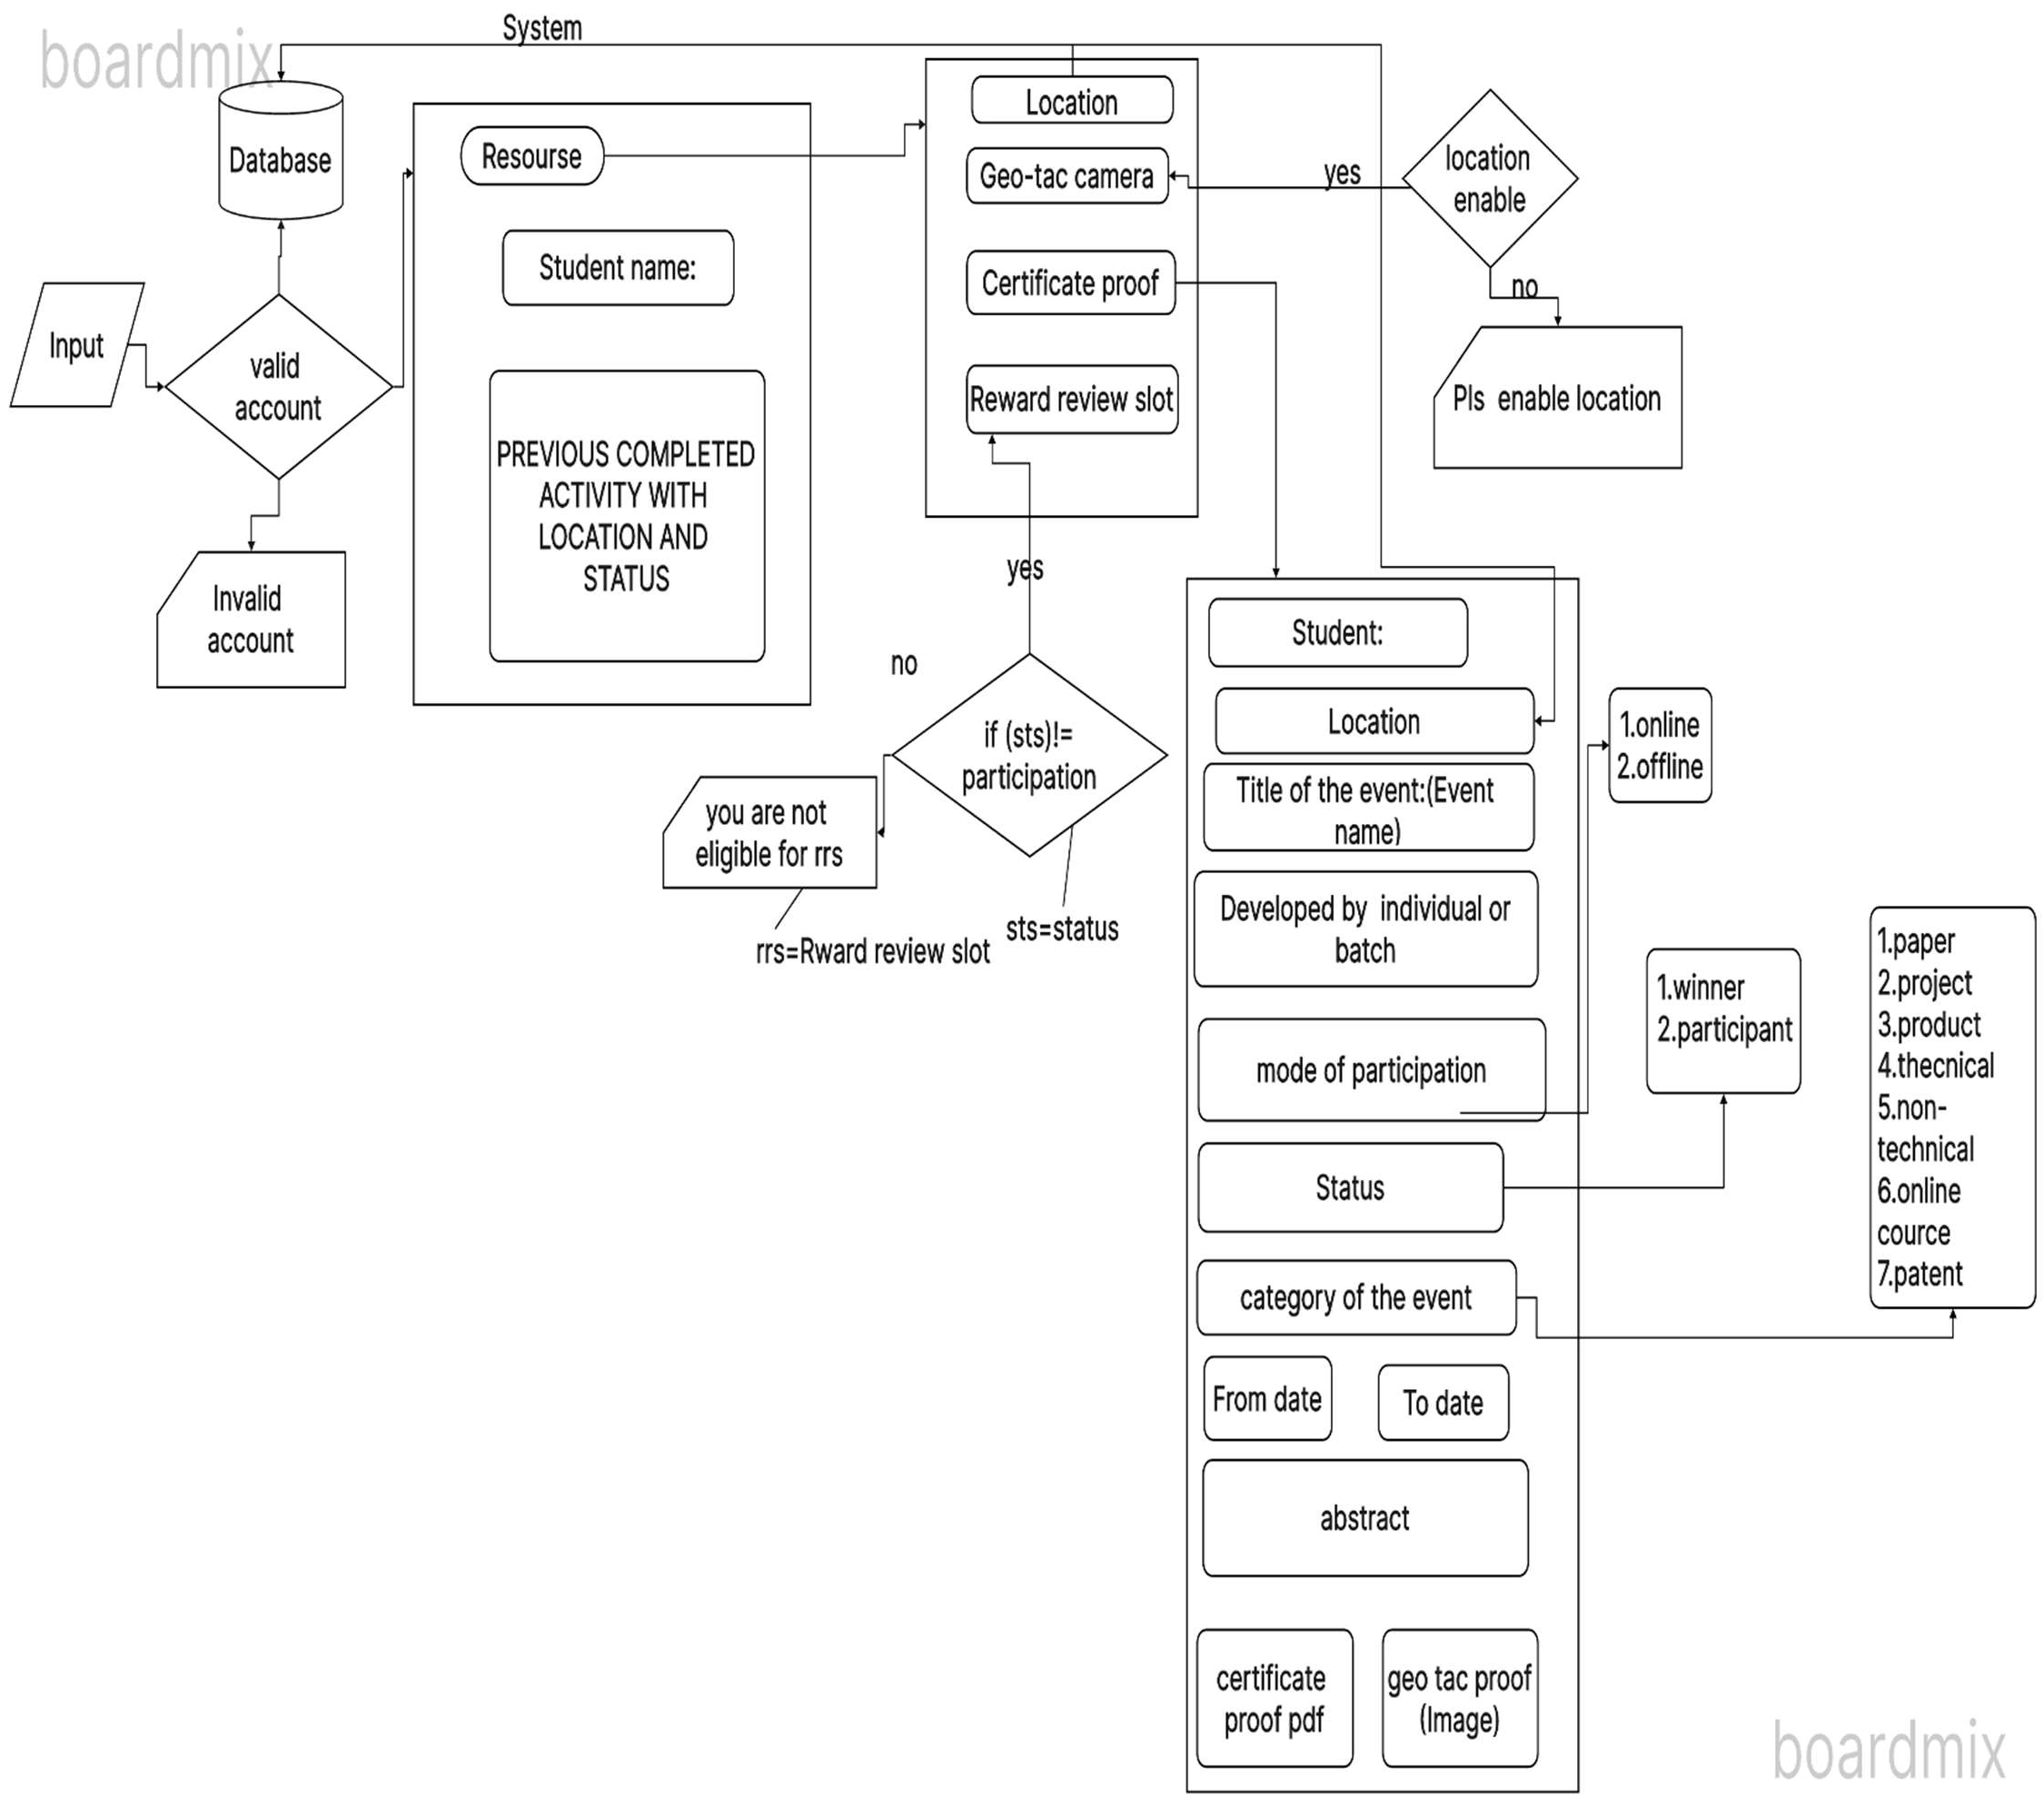

**Admin Interface:**

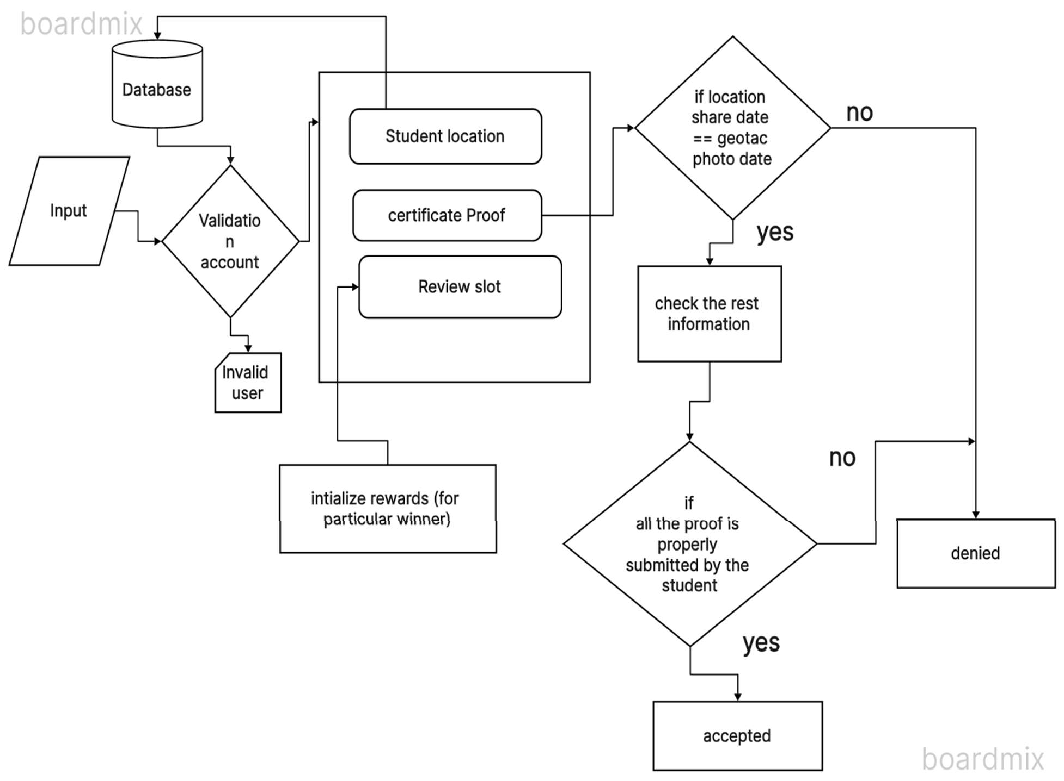

Recently, our shared locations have been displayed, indicating the college certificates need to upload. We have selected a specific location for this purpose.

## Title of the event:

Selecting Event and College : participants are required to choose the specific event they wish to attend, along with the name of the college hosting the event and the location of the college.

## Developed By individual or group:

Individual or Group Students have the option to choose whether they want to participate individually or as part of a group. If they choose to participate as a group, they can form a team with a maximum of nine members.

## Mode of participation:

There are two modes of participation available for students in the event:

* + Online participation
  + Offline participation

## Status:

There are three types of participation:

* + Winner
  + Participant

## Category of the event:

There are seven categories available for the event in the COE page

* + Paper
  + Product
  + Project
  + Technical
  + Non-technical
  + Patent
  + Online course

## Reward-Review Slot:

If the type of participant is not "Participant," then book the slot. Otherwise, display an error message stating that you are not eligible to book the slot.

## Admin Access:

The administrator tracks the location of the participants and approves their proof. If the participant is a winner the administrator allocates reward points to the student.

## Certificate approval:

To approve a certificate, the administrator checks if the location sharing date and the event date fall within the starting and ending dates. Additionally, the administrator verifies all other proofs. Only if all the proofs are correct, the administrator approves the certificate. Otherwise, the certificate is denied.

## Initializing Rewards (Winner):

When a student books a reward review slot, the administrator assigns them initial reward points. The administrator also designates the reviewer's name and the venue for the review.

Based on the review provided by the administrator, the student receives rewards from the allocated rewards pool. The rewards are distributed individually, taking into account the quality of their review. Additionally, for group submissions, the rewards are divided among the members of the group based on their respective contributions to the review. The division of reward points is determined by the number of people in the group.

# UI/UX DESIGN FOR THE PORTAL:

**Login page:**

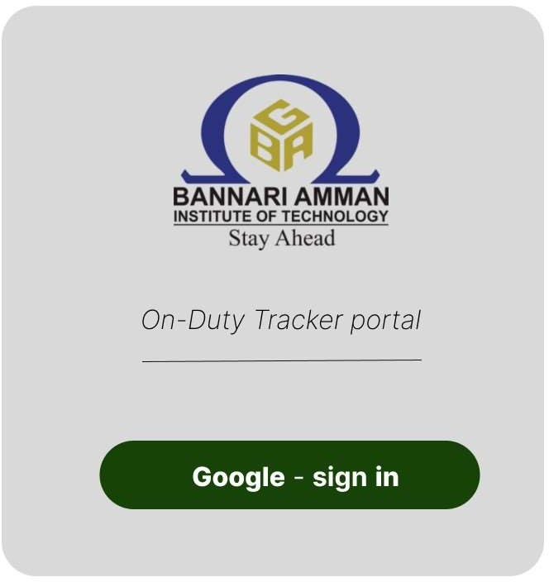

# Home page:

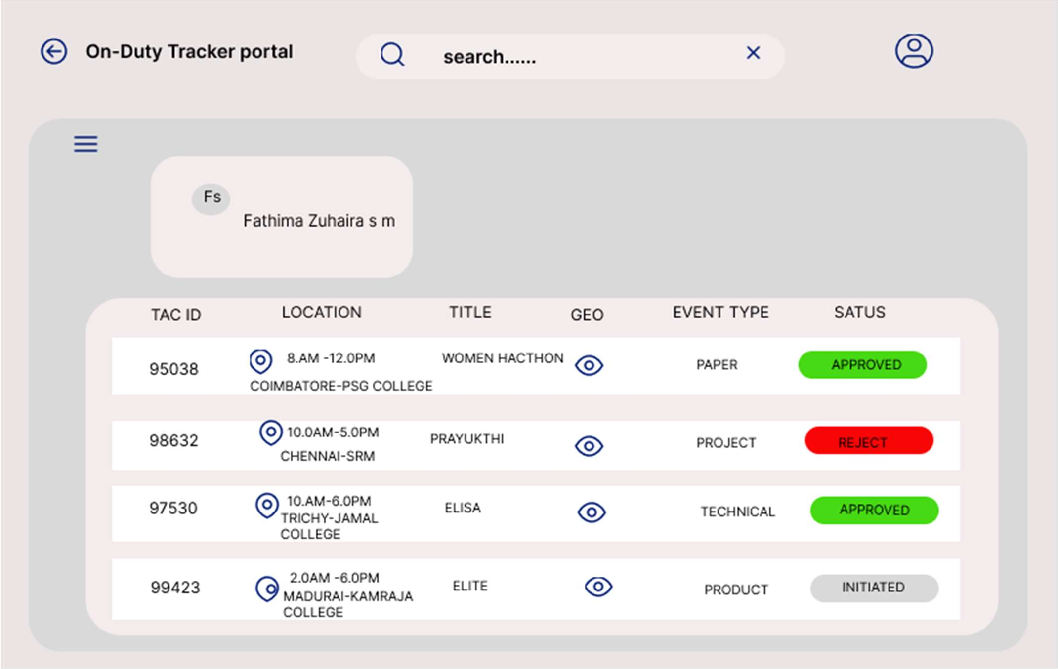

**About:**

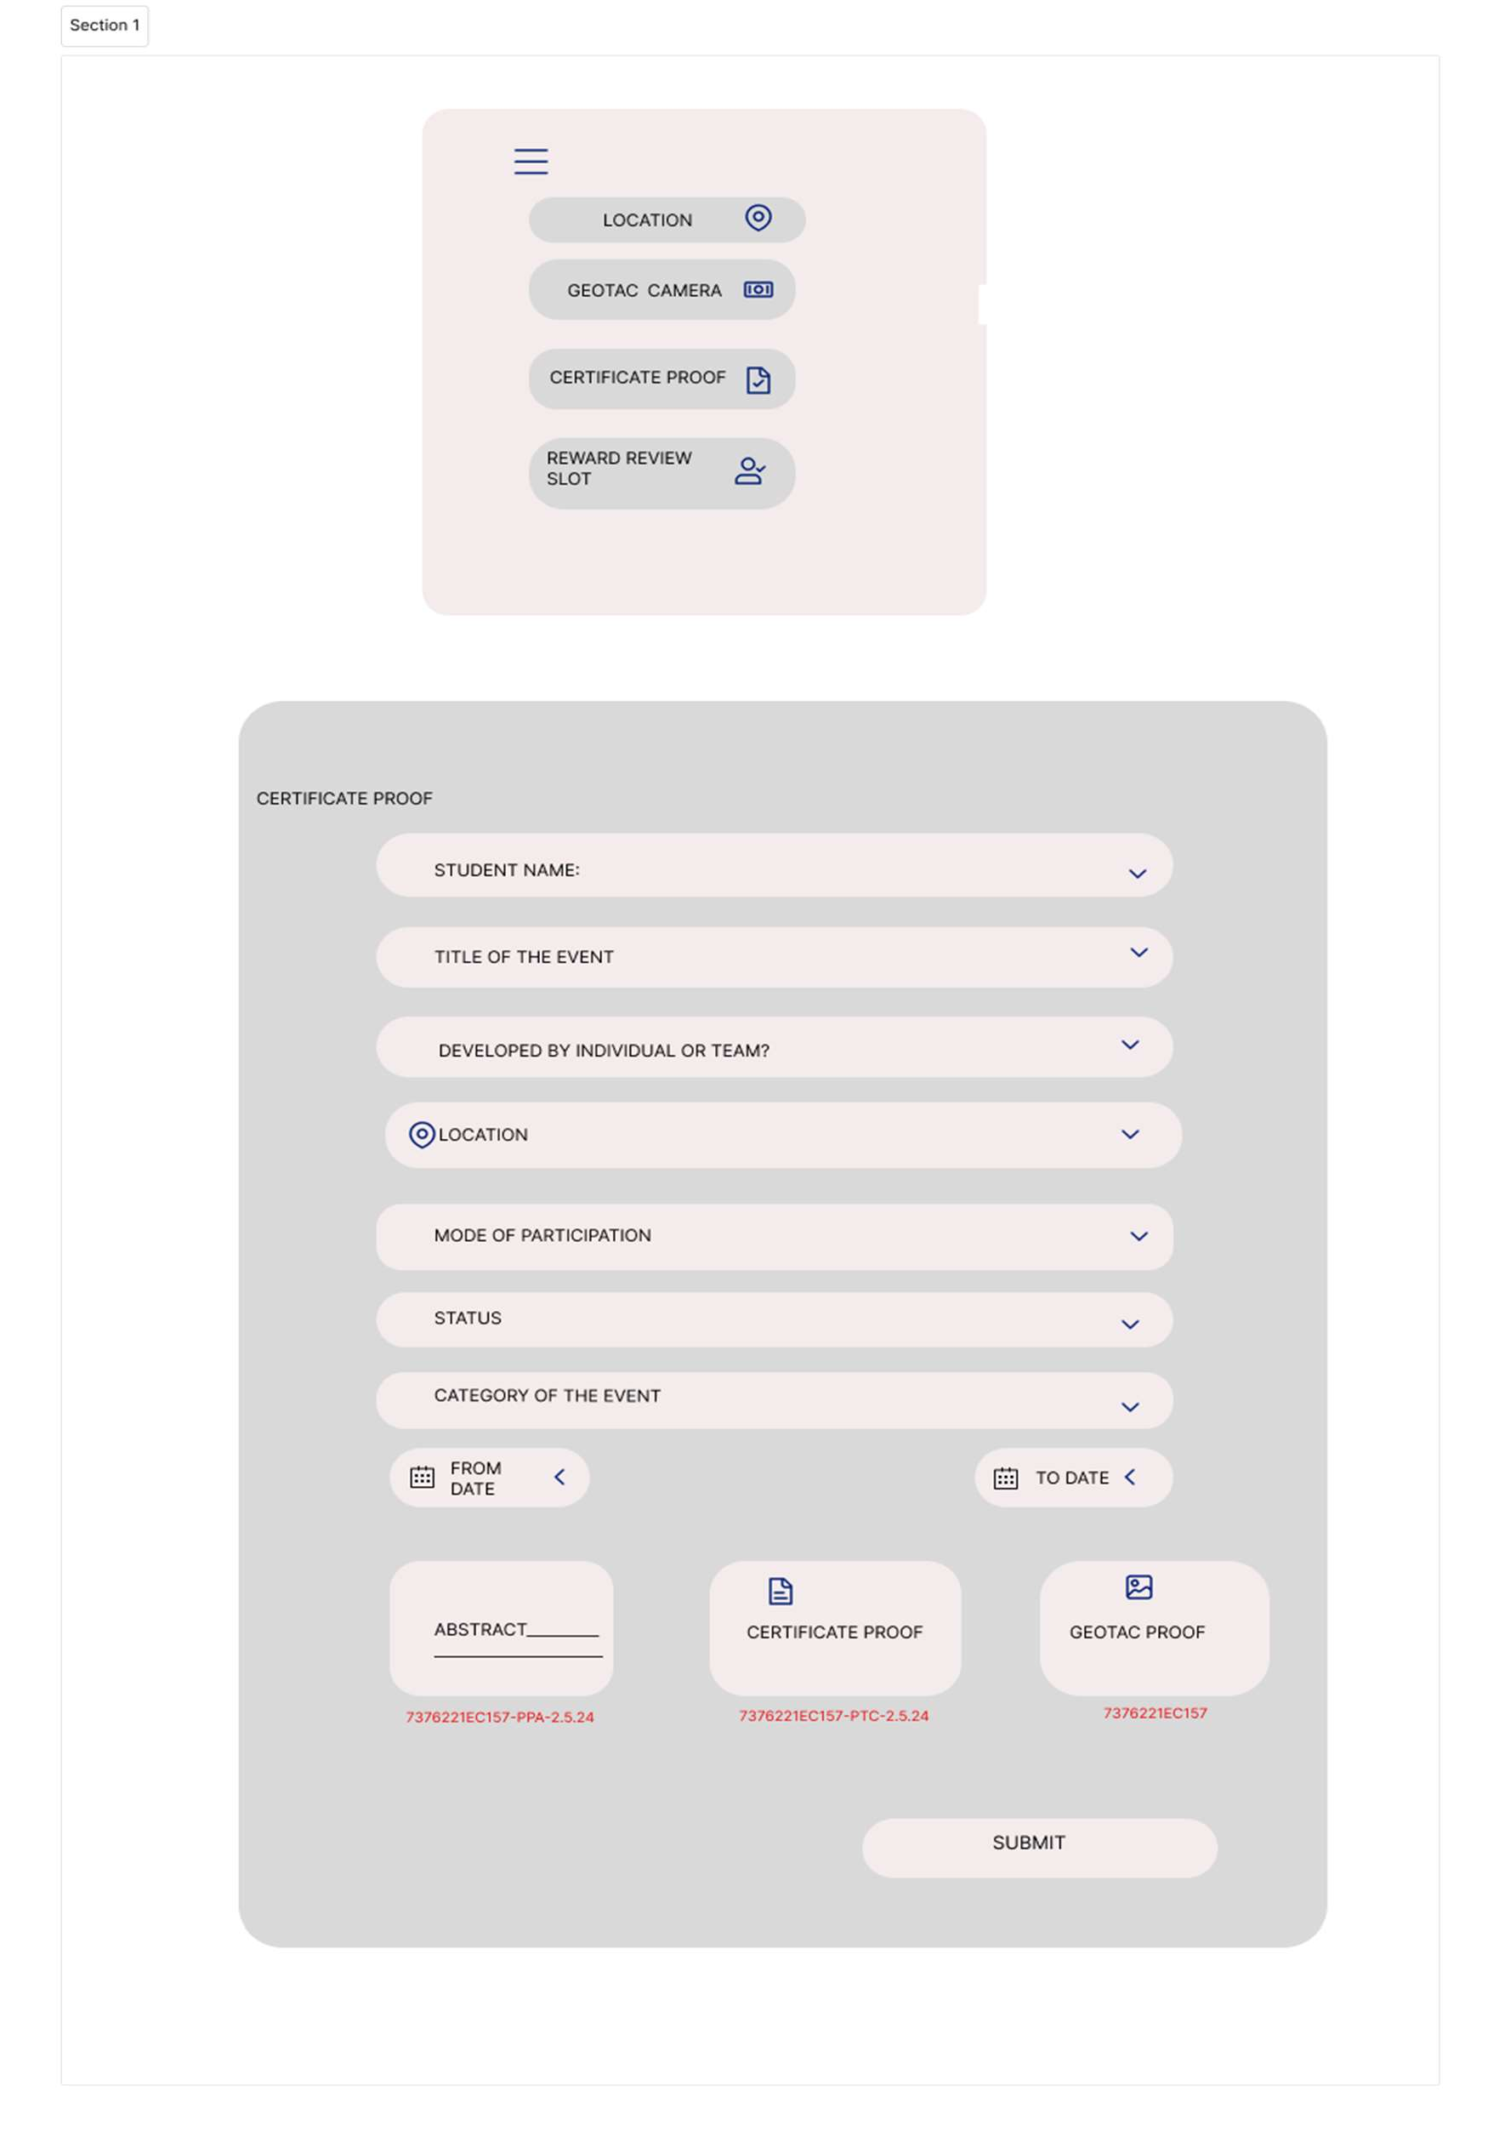

# Admin view:

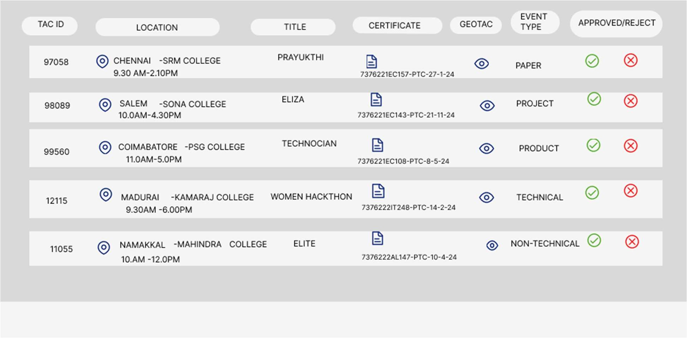

**STACK –** PYTHON STACK(AI)**:**

|  |  |
| --- | --- |
| Front End | * HTML * CSS * JavaScript |
| Back End | * Python * Django (Python Web) |
| Database | * PostgreSQL * MySQL |
| API | * Open API * Soap APIs * Rest Full API |